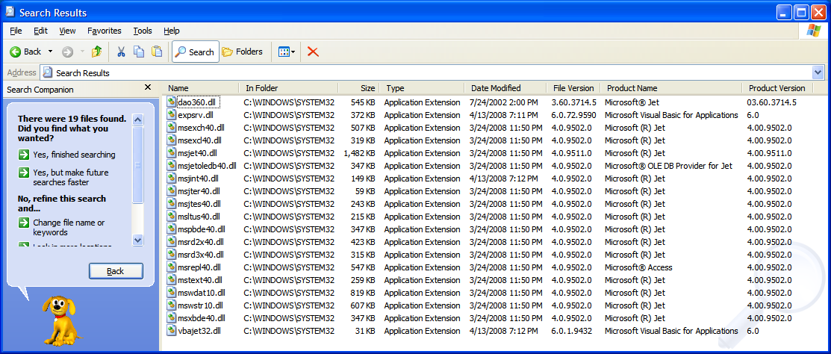

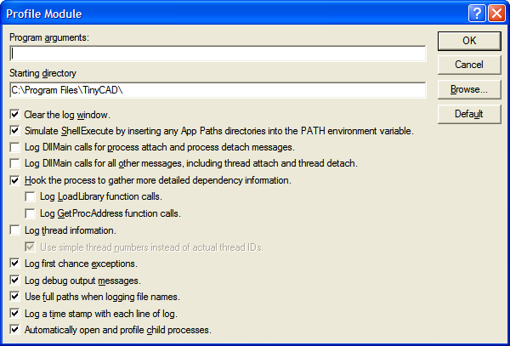

--------------------------------------------------------------------------------
Starting profile on 2/8/2009 at 5:59:04 PM

Operating System: Microsoft Windows XP Professional (32-bit), version 5.01.2600 Service Pack 3
Program Executable: c:\program files\tinycad\TINYCAD.EXE
Program Arguments:
Starting Directory: C:\Program Files\TinyCAD\
Search Path: C:/Program Files/Texas Instruments/xdctools_3_10;C:\WINDOWS\system32;C:\WINDOWS;C:\WINDOWS\System32\Wbem;C:\Program Files\Altium Designer Summer 08\System;C:\Program Files\CollabNet Subversion Server;C:\Program Files\doxygen\bin;C:\Program Files\QuickTime\QTSystem\;C:\Program Files\Microsoft SQL Server\90\Tools\binn\;C:\Program Files\TortoiseSVN\bin;C:/Program Files/Texas Instruments/xdctools_3_10;C:\Program Files\CVSNT\;c:\usr\local\bin;c:\python26

Options Selected:
Simulate ShellExecute by inserting any App Paths directories into the PATH environment variable.
Hook the process to gather more detailed dependency information.
Log first chance exceptions.
Log debug output messages.
Use full paths when logging file names.
Log a time stamp with each line of log.
Automatically open and profile child processes.
--------------------------------------------------------------------------------

00:00:00.000: Started "c:\program files\tinycad\TINYCAD.EXE" (process 0xC98) at address 0x00400000. Successfully hooked module.
00:00:00.010: Loaded "c:\windows\system32\NTDLL.DLL" at address 0x7C900000. Successfully hooked module.
00:00:00.150: Loaded "c:\windows\system32\KERNEL32.DLL" at address 0x7C800000. Successfully hooked module.
00:00:00.160: Injected "c:\program files\dependency walker\DEPENDS.DLL" at address 0x08370000.
00:00:00.200: Loaded "c:\windows\system32\VERSION.DLL" at address 0x77C00000. Successfully hooked module.
00:00:00.210: Loaded "c:\program files\tinycad\ICONV.DLL" at address 0x10000000. Successfully hooked module.
00:00:00.220: Loaded "c:\windows\system32\MSVCRT.DLL" at address 0x77C10000. Successfully hooked module.
00:00:00.230: Loaded "c:\program files\tinycad\LIBPNG13.DLL" at address 0x00340000. Successfully hooked module.
00:00:00.240: Loaded "c:\program files\tinycad\ZLIB1.DLL" at address 0x00360000. Successfully hooked module.
00:00:00.250: Loaded "c:\windows\system32\MSVCR71.DLL" at address 0x7C360000. Successfully hooked module.
00:00:00.260: Loaded "c:\windows\system32\USER32.DLL" at address 0x7E410000. Successfully hooked module.
00:00:00.260: Loaded "c:\windows\system32\GDI32.DLL" at address 0x77F10000. Successfully hooked module.
00:00:00.270: Loaded "c:\windows\system32\COMDLG32.DLL" at address 0x763B0000. Successfully hooked module.
00:00:00.280: Loaded "c:\windows\system32\ADVAPI32.DLL" at address 0x77DD0000. Successfully hooked module.
00:00:00.290: Loaded "c:\windows\system32\RPCRT4.DLL" at address 0x77E70000. Successfully hooked module.
00:00:00.290: Loaded "c:\windows\system32\SECUR32.DLL" at address 0x77FE0000. Successfully hooked module.
00:00:00.300: Loaded "c:\windows\winsxs\x86_microsoft.windows.common-controls_6595b64144ccf1df_6.0.2600.5512_x-ww_35d4ce83\COMCTL32.DLL" at address 0x773D0000. Successfully hooked module.
00:00:00.300: Loaded "c:\windows\system32\SHLWAPI.DLL" at address 0x77F60000. Successfully hooked module.
00:00:00.320: Loaded "c:\windows\system32\SHELL32.DLL" at address 0x7C9C0000. Successfully hooked module.
00:00:00.320: Loaded "c:\windows\system32\WINSPOOL.DRV" at address 0x73000000. Successfully hooked module.
00:00:00.330: Loaded "c:\windows\system32\OLEDLG.DLL" at address 0x7DF70000. Successfully hooked module.
00:00:00.330: Loaded "c:\windows\system32\OLE32.DLL" at address 0x774E0000. Successfully hooked module.
00:00:00.340: Loaded "c:\windows\system32\OLEAUT32.DLL" at address 0x77120000. Successfully hooked module.
00:00:00.340: Loaded "c:\windows\system32\WSOCK32.DLL" at address 0x71AD0000. Successfully hooked module.
00:00:00.350: Loaded "c:\windows\system32\WS2_32.DLL" at address 0x71AB0000. Successfully hooked module.
00:00:00.350: Loaded "c:\windows\system32\WS2HELP.DLL" at address 0x71AA0000. Successfully hooked module.
00:00:00.360: Entrypoint reached. All implicit modules have been loaded.
00:00:00.410: Loaded "c:\windows\system32\UXTHEME.DLL" at address 0x5AD70000. Successfully hooked module.
00:00:00.450: Loaded "c:\progra~1\zonela~1\zoneal~1\mailfr~1\MLFHOOK.DLL" at address 0x24000000. Successfully hooked module.
00:00:00.551: Loaded "c:\windows\system32\CLBCATQ.DLL" at address 0x76FD0000. Successfully hooked module.
00:00:00.561: Loaded "c:\windows\system32\COMRES.DLL" at address 0x77050000. Successfully hooked module.
00:00:00.581: Loaded "c:\progra~1\common~1\micros~1\dao\DAO360.DLL" at address 0x1B720000. Successfully hooked module.
00:00:00.621: Loaded "c:\windows\system32\MSJET40.DLL" at address 0x1B000000. Successfully hooked module.
00:00:00.621: Loaded "c:\windows\system32\MSWSTR10.DLL" at address 0x1B5D0000. Successfully hooked module.
00:00:00.711: Loaded "c:\windows\system32\VBAJET32.DLL" at address 0x0F9A0000. Successfully hooked module.
00:00:00.731: Loaded "c:\windows\system32\EXPSRV.DLL" at address 0x0F9C0000. Successfully hooked module.
00:00:00.791: Unloaded "c:\windows\system32\VBAJET32.DLL" at address 0x0F9A0000.
00:00:00.811: Loaded "c:\program files\ultralibrarian\MSJTES40.DLL" at address 0x1B810000. Successfully hooked module.
00:00:00.831: Loaded "c:\windows\system32\VBAJET32.DLL" at address 0x0F9A0000. Successfully hooked module.
00:00:01.101: Mapped "c:\program files\tinycad\TINYCAD.EXE" as a data file into memory at address 0x00400000.
00:00:01.101: Mapped "c:\program files\tinycad\TINYCAD.EXE" as a data file into memory at address 0x00400000.
00:01:48.326: First chance exception 0xC0000005 (Access Violation) occurred in "c:\windows\system32\KERNEL32.DLL" at address 0x7C809F42.
00:01:48.366: Unloaded "c:\windows\system32\MSJET40.DLL" at address 0x1B000000.
00:01:48.366: Unloaded "c:\progra~1\common~1\micros~1\dao\DAO360.DLL" at address 0x1B720000.
00:01:48.366: Unloaded "c:\program files\ultralibrarian\MSJTES40.DLL" at address 0x1B810000.
00:01:48.366: Unloaded "c:\windows\system32\EXPSRV.DLL" at address 0x0F9C0000.
00:01:48.376: Exited "c:\program files\tinycad\TINYCAD.EXE" (process 0xC98) with code 0 (0x0).

